Revision History

|  |  |  |
| --- | --- | --- |
| **Revision** | **Description of Change** | **Revision date** |
| 1.0 | Test report phase 1 | 2019-09-17 |
|  |  |  |
|  |  |  |
|  |  |  |
|  |  |  |
|  |  |  |
|  |  |  |
|  |  |  |
|  |  |  |
|  |  |  |
|  |  |  |

**TABLE OF CONTENTS**

[Introduction 3](#_Toc12884135)

[1 Test Object 4](#_Toc12884136)

[2 Test Environment 5](#_Toc12884137)

[3 Testing work （Phase 1） 6](#_Toc12884138)

[3.1 Test Environment 6](#_Toc12884139)

[3.2 Test scenario and strategy 7](#_Toc12884140)

[3.3 Test Tool 7](#_Toc12884141)

[3.4 Database setting 7](#_Toc12884142)

[3.5 IIS setting 8](#_Toc12884143)

[3.6 Test Object version 8](#_Toc12884144)

[3.7 Background data 8](#_Toc12884145)

[3.8 Test Error 9](#_Toc12884146)

[3.9 Test result of PS server 9](#_Toc12884147)

[Test result of PS transactions 9](#_Toc12884148)

[Transaction summary result of PS 10](#_Toc12884149)

[Transaction response time result of PS 11](#_Toc12884150)

[3.10 Test result of Web service 12](#_Toc12884151)

[Test Statistic Report of Web 12](#_Toc12884152)

[Transaction summary result of Web 14](#_Toc12884153)

[Transaction response time result of Web 14](#_Toc12884154)

[3.11 Performance bottleneck analysis 15](#_Toc12884155)

[Hardware usage analysis- Main Server 16](#_Toc12884156)

[Hardware usage analysis- PS Server 18](#_Toc12884157)

[SQL Server resource usage analysis 23](#_Toc12884158)

[MS IIS resource usage analysis 25](#_Toc12884159)

[3.12 Test Conclusion 27](#_Toc12884160)

[3.13 Tune suggestion: 28](#_Toc12884161)

[System related: 28](#_Toc12884162)

[Database related: 28](#_Toc12884163)

[4 Testing work （Phase 1） 30](#_Toc12884164)

[4.1 Test Environment 30](#_Toc12884165)

[4.2 Test scenario and strategy 30](#_Toc12884166)

[4.3 Test Tool 31](#_Toc12884167)

[4.4 Database setting 31](#_Toc12884168)

[4.5 IIS setting 31](#_Toc12884169)

[4.6 Test Object version 31](#_Toc12884170)

[4.7 Background data 31](#_Toc12884171)

[4.8 Test Error 32](#_Toc12884172)

[4.9 Test result of PS server 33](#_Toc12884173)

[Test result of PS transactions 33](#_Toc12884174)

[Transaction summary result of PS 34](#_Toc12884175)

[Transaction response time result of PS 35](#_Toc12884176)

[4.10 Test result of Web service 36](#_Toc12884177)

[Test Statistic Report of Web 36](#_Toc12884178)

[Transaction summary result of Web 38](#_Toc12884179)

[Transaction response time result of Web 38](#_Toc12884180)

[4.11 Performance bottleneck analysis 40](#_Toc12884181)

[Hardware usage analysis- Main Server 40](#_Toc12884182)

[Hardware usage analysis- PS Server 41](#_Toc12884183)

[SQL Server resource usage analysis 47](#_Toc12884184)

[MS IIS resource usage analysis 50](#_Toc12884185)

[4.12 Test Conclusion 52](#_Toc12884186)

# Introduction

The PUMA MR3 performance testing works will focus on main work flow of the Print Server of Kiosk (PS). Develop team had do some enhance operations for system. We will verify these change should works and do not affect the main work flow.

The PUMA PS system will integrated with other 3rd systems like HIS, RIS, LIS etc. System will synchronize 3rd party data and provide the film include gray and color type and report printing services. The PUMA system will integrate with PS and get the patient information and images data from PS system.

We should confirm the performance of PS system will meet the requirements on real work environments. Ensure the new added features will not affect main workflow of PS system.

# Test Object

The PUMA system will support film and report printing and notice push service for different departments of entire hospital.

We will integrate the 3rd party system and patients can print their films and reports in ONE terminal. The patient can print their color films to paper or films. Patients can query different information, and get report status notice service from the product.

PUMA MR1 system will provide the patient images data upload service for Cloud Film system. System will provide the patient can print their color films to film or paper media. The patient can view the image files including picture and DICOM type from WeChat platform or by scanning from 2D image code.

Notice: We will not test the images upload feature in performance testing.

The architecture as follow:

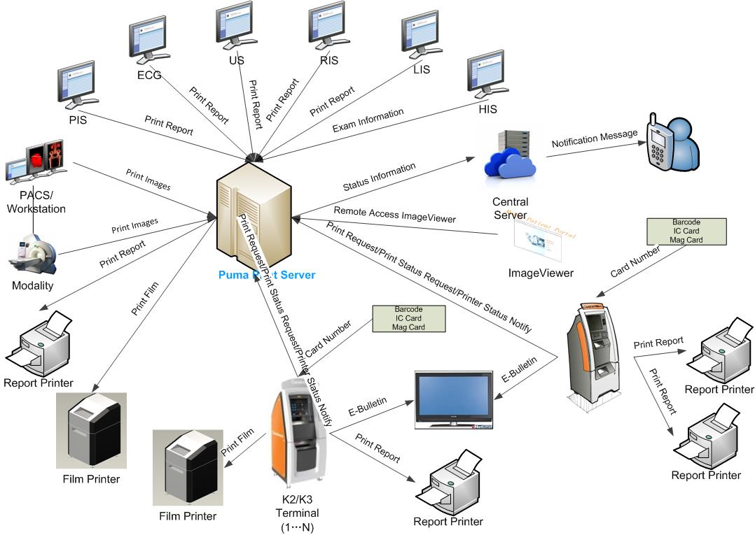Figure 3.1.2

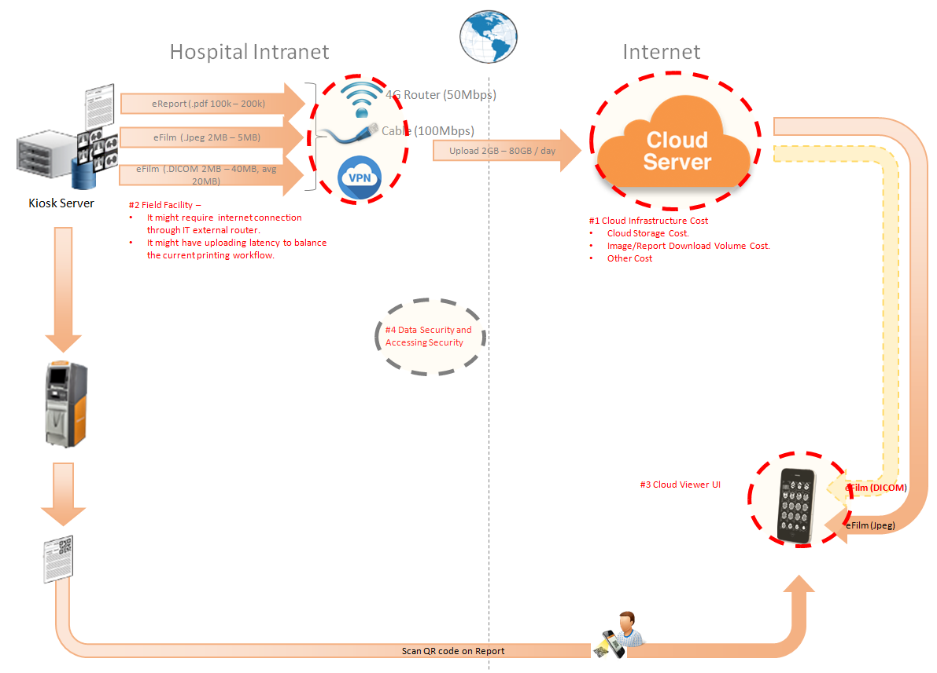Figure 3.1.2

The performance testing work will focus on the PS system. We will simulate the web service call and send them to PS server, and monitor the transactions response time, service performance and hardware resource usage. This scenario will include the 3rd request, report archived, gray and color film and report print, web query and update status operations etc.

# Test Environment

The detailed hardware configurations of all servers are described as follow:

|  |  |  |  |  |  |  |
| --- | --- | --- | --- | --- | --- | --- |
| **Computer name** | **CPU** | **Memory** | **HD** | **OS** | **Other** | **Comments** |
| PUMA Main Server | Intel(R) Xeon® Bronze CPU 3140 @ 1.70 \* 6 | 16GB | 300GB | Windows 2012 R2 64bit |  |  |
| PUMA Store Server | Intel(R) Xeon® Bronze CPU 3140 @ 1.70 \* 6 | 16GB | 8T | Windows 2012 R2 64bit |  |  |
| PUMA virtual server | Intel(R) Xeon® Bronze CPU 3140 @ 1.70 \* 6 | 12GB | 7T | Windows 2012 R2 64bit | SQL server 2008 Sp3 | PS 3.0.5.0.3300 |
| Terminal | Intel(R) Celeron CPU J1900 2.0GHz | 4GB | 450GB | Windows 10 Enterprise 2016 | AUTOIT 3.0 |  |

Table 1 Hardware Configuration

# Testing work （Phase 1）

## Test Environment

The detailed hardware configurations of all servers are described as follow:

|  |  |  |  |  |  |  |
| --- | --- | --- | --- | --- | --- | --- |
| **Computer name** | **CPU** | **Memory** | **HD** | **OS** | **Other** | **Comments** |
| PUMA Main Server | Intel(R) Xeon® Bronze CPU 3140 @ 1.70 \* 6 | 16GB | 300GB | Windows 2012 R2 64bit |  |  |
| PUMA Store Server | Intel(R) Xeon® Bronze CPU 3140 @ 1.70 \* 6 | 16GB | 8T | Windows 2012 R2 64bit |  |  |
| PUMA virtual server | Intel(R) Xeon® Bronze CPU 3140 @ 1.70 \* 6 | 12GB | 7T | Windows 2012 R2 64bit | SQL server 2008 Sp3 | PS 3.0.5.0.3300 |
| Terminal | Intel(R) Celeron CPU J1900 2.0GHz | 4GB | 450GB | Windows 10 Enterprise 2016 | AUTOIT 3.0 |  |

Table 1 Hardware Configuration

## Test scenario and strategy

Virtual User: 59 Users

Duration: 8 hour

Description: Use the test tool simulates the patient operations. Monitor the server software and hardware resource usage. The detail information as follow:

1. Use automation tool simulate the doctor print film work. Simulate 10 workstations print films to PS server every 60 seconds in 8 hours.
2. Use LR tool simulate 8 K2/K3 terminals to print gray films. Each client prints one film which size is 10MB random 5 to 30 seconds.
3. Use LR tool simulate 21 users to do paper report archive and print operations. Each client archive report in random 5 to 30 seconds and size is random with 100kb or 4Mb.
4. The OCR setting will has rule configuration from test tool in step1 and thread setting is set as 4. The OCR rule will has no ROI setting of patient id and accession number in OCR.
5. Simulate 10 users to do the query information, view monitor page, query reconciliation films and report, expand the record, change the status, set holding time and other operations in work list. The users will execute the operations random 60 to 120 seconds.
6. Monitor the transaction response time.
7. Monitor the hardware resource usage on PS.
8. Monitor the resource usage for database on PS.
9. Start/Stop 2 virtual users every 10 seconds and run the scenario for 8 hours.

Note:

We will do the performance testing work under stress for system. If system can work well under current stress and the transaction process ability meets the requirement, we will give the conclusion the system performance is pass.

## Test Tool

Load Runner 12.

## Database setting

Memory: Set the min and max memory size to 4GB.

Index fill factor: 80.

File: Increase the data and log files size and the rule is increase 500Mb as fixed size.

Settings: Cost threshold for parallelism to 60.

## IIS setting

Connection: Set the max connection value to 4000 and keep other setting as default.

## Test Object version

PUMA 3.0.5.0 B33 + worklist search patch.

## Background data

We will simulate 1,000,000 records in the PS as background data. The data size is calculated by typical site. We will stop the SMS and LRU services of PS in order to keep the history data. These data will be added by automation scripts, test tool or SQL script. The detail data information as follow:

|  |  |  |
| --- | --- | --- |
| No. | Items | Amount |
| 1 | Patients | >=1,000,000 |
| 2 | Films | >=1,000,000 |
| 3 | Reports | >=1,000,000 |
| 4 | Exams | >=1,000,000 |
| 5 | Unprinted Films | >=700,000 |
| 6 | Unprinted Reports | >=300,000 |

## Test Error

There is 39 transactions error during the testing work.

## Test result of PS server

### Test result of PS transactions

After the performance testing works, the transactions result of PS print module as follow:

|  |  |
| --- | --- |
| Analysis Summary | Period: 9/16/2019 3:32 PM - 9/16/2019 11:39 PM |

|  |  |
| --- | --- |
| **Scenario Name:** | E:\ECS\Performance\Script\208\ScenarioPUMA\_MR2\_Reliability\_161.lrs |
| **Results in Session:** | c:\Users\Administrator\AppData\Local\Temp\res1163\res1163.lrr |
| **Duration:** | 8 hours, 7 minutes and 2 seconds. |

|  |
| --- |
| Statistics Summary |

|  |  |  |
| --- | --- | --- |
| [**Maximum Running Users:**](file:///D:\Carestream%20Work\MR3\Performance\LR%20result\PS%20result\MR3%20Performance%20result\phase1_20190917\VuserStateGraph) |  | 29 |
| [**Total Throughput (bytes):**](file:///D:\Carestream%20Work\MR3\Performance\LR%20result\PS%20result\MR3%20Performance%20result\phase1_20190917\Throughput) | [Show SLA Results](slarules:total_throughput) | 18,354,362 |
| [**Average Throughput (bytes/second):**](file:///D:\Carestream%20Work\MR3\Performance\LR%20result\PS%20result\MR3%20Performance%20result\phase1_20190917\Throughput) | [Show SLA Results](slarules:average_throughput) | 628 |
| [**Total Hits:**](file:///D:\Carestream%20Work\MR3\Performance\LR%20result\PS%20result\MR3%20Performance%20result\phase1_20190917\HitsperSecond) | [Show SLA Results](slarules:total_hits) | 18,969 |
| [**Average Hits per Second:**](file:///D:\Carestream%20Work\MR3\Performance\LR%20result\PS%20result\MR3%20Performance%20result\phase1_20190917\HitsperSecond) | [Show SLA Results](slarules:average_hits) | 0.649 | [**View HTTP Responses Summary**](file:///D:\Carestream%20Work\MR3\Performance\LR%20result\PS%20result\MR3%20Performance%20result\phase1_20190917\phase1_20190917.html#1) |
| [**Total Errors:**](file:///D:\Carestream%20Work\MR3\Performance\LR%20result\PS%20result\MR3%20Performance%20result\phase1_20190917\TotalErrorsPerSecond) | [Show SLA Results](slarules:errors_per_second) | 54 |  |

|  |  |  |
| --- | --- | --- |
| |  | | --- | | You can define SLA data using the [SLA configuration wizard](slaconfig:) | | You can analyze transaction behavior using the [Analyze Transaction mechanism](analyze:) | |

|  |
| --- |
| Transaction Summary |

|  |  |  |  |  |
| --- | --- | --- | --- | --- |
| [**Transactions:**](file:///D:\Carestream%20Work\MR3\Performance\LR%20result\PS%20result\MR3%20Performance%20result\phase1_20190917\TransactionSummary) | Total Passed: 98,673 | Total Failed: 39 | Total Stopped: 0 | [**Average Response Time**](file:///D:\Carestream%20Work\MR3\Performance\LR%20result\PS%20result\MR3%20Performance%20result\phase1_20190917\ResponseTime) |

|  |  |  |  |  |  |  |  |  |
| --- | --- | --- | --- | --- | --- | --- | --- | --- |
| **Transaction Name** | **Minimum** | **Average** | **Maximum** | **Std. Deviation** | **90 Percent** | **Pass** | **Fail** | **Stop** |
| [Create New Patient](file:///D:\Carestream%20Work\MR3\Performance\LR%20result\PS%20result\MR3%20Performance%20result\phase1_20190917\ResponseTime0000(Create%20New%20Patient)0000) | 0.171 | 0.288 | 1.732 | 0.109 | 0.437 | 5,891 | 0 | 0 |
| [Film Create\_PrintTask](file:///D:\Carestream%20Work\MR3\Performance\LR%20result\PS%20result\MR3%20Performance%20result\phase1_20190917\ResponseTime0000(Film%20Create_PrintTask)0000) | 0.062 | 0.306 | 52.416 | 1.614 | 0.374 | 2,935 | 0 | 0 |
| [Film GetTaskID\_Fail](file:///D:\Carestream%20Work\MR3\Performance\LR%20result\PS%20result\MR3%20Performance%20result\phase1_20190917\ResponseTime0000(Film%20GetTaskID_Fail)0000) | 0 | 0 | 0 | 0 | 0 | 0 | 8 | 0 |
| [Film PrintTask](file:///D:\Carestream%20Work\MR3\Performance\LR%20result\PS%20result\MR3%20Performance%20result\phase1_20190917\ResponseTime0000(Film%20PrintTask)0000) | 0.031 | 0.146 | 2.2 | 0.104 | 0.265 | 2,927 | 0 | 0 |
| [Film PrintTask\_Result\_Correct](file:///D:\Carestream%20Work\MR3\Performance\LR%20result\PS%20result\MR3%20Performance%20result\phase1_20190917\ResponseTime0000(Film%20PrintTask_Result_Correct)0000) | 0 | 0 | 0.016 | 0.001 | 0 | 2,927 | 0 | 0 |
| [Film TerminalStatus](file:///D:\Carestream%20Work\MR3\Performance\LR%20result\PS%20result\MR3%20Performance%20result\phase1_20190917\ResponseTime0000(Film%20TerminalStatus)0000) | 0 | 0.139 | 42.12 | 1.437 | 0.14 | 2,927 | 0 | 0 |
| [Film\_PrintStatus\_CheckService](file:///D:\Carestream%20Work\MR3\Performance\LR%20result\PS%20result\MR3%20Performance%20result\phase1_20190917\ResponseTime0000(Film_PrintStatus_CheckService)0000) | 0 | 0.095 | 44.413 | 0.868 | 0.156 | 10,180 | 0 | 0 |
| [Notify File 100k](file:///D:\Carestream%20Work\MR3\Performance\LR%20result\PS%20result\MR3%20Performance%20result\phase1_20190917\ResponseTime0000(Notify%20File%20100k)0000) | 0.155 | 0.517 | 27.16 | 0.86 | 0.796 | 5,761 | 1 | 0 |
| [Notify File 4M](file:///D:\Carestream%20Work\MR3\Performance\LR%20result\PS%20result\MR3%20Performance%20result\phase1_20190917\ResponseTime0000(Notify%20File%204M)0000) | 0.234 | 0.628 | 3.385 | 0.352 | 0.967 | 128 | 0 | 0 |
| [Report Print Task Correct](file:///D:\Carestream%20Work\MR3\Performance\LR%20result\PS%20result\MR3%20Performance%20result\phase1_20190917\ResponseTime0000(Report%20%20Print%20Task%20Correct)0000) | 0 | 0 | 0.001 | 0 | 0 | 5,863 | 0 | 0 |
| [Report Print Task fail](file:///D:\Carestream%20Work\MR3\Performance\LR%20result\PS%20result\MR3%20Performance%20result\phase1_20190917\ResponseTime0000(Report%20%20Print%20Task%20fail)0000) | 0 | 0 | 0 | 0 | 0 | 0 | 18 | 0 |
| [Report Create\_PrintTask](file:///D:\Carestream%20Work\MR3\Performance\LR%20result\PS%20result\MR3%20Performance%20result\phase1_20190917\ResponseTime0000(Report%20Create_PrintTask)0000) | 0.069 | 0.227 | 2.09 | 0.132 | 0.367 | 5,883 | 0 | 0 |
| [Report PrintTask](file:///D:\Carestream%20Work\MR3\Performance\LR%20result\PS%20result\MR3%20Performance%20result\phase1_20190917\ResponseTime0000(Report%20PrintTask)0000) | 0.031 | 0.17 | 7.894 | 0.168 | 0.302 | 5,880 | 3 | 0 |
| [Report PrintTask Status Check](file:///D:\Carestream%20Work\MR3\Performance\LR%20result\PS%20result\MR3%20Performance%20result\phase1_20190917\ResponseTime0000(Report%20PrintTask%20Status%20Check)0000) | 0 | 0.088 | 27.16 | 0.585 | 0.147 | 6,197 | 2 | 0 |
| [Report QueryFilmReportInfo](file:///D:\Carestream%20Work\MR3\Performance\LR%20result\PS%20result\MR3%20Performance%20result\phase1_20190917\ResponseTime0000(Report%20QueryFilmReportInfo)0000) | 0.079 | 0.292 | 28.673 | 0.843 | 0.421 | 11,766 | 0 | 0 |
| [Report TerminalStatus](file:///D:\Carestream%20Work\MR3\Performance\LR%20result\PS%20result\MR3%20Performance%20result\phase1_20190917\ResponseTime0000(Report%20TerminalStatus)0000) | 0 | 0.088 | 28.111 | 0.59 | 0.14 | 11,759 | 7 | 0 |
| [Report Update PrintTask](file:///D:\Carestream%20Work\MR3\Performance\LR%20result\PS%20result\MR3%20Performance%20result\phase1_20190917\ResponseTime0000(Report%20Update%20PrintTask)0000) | 0.031 | 0.176 | 16.676 | 0.397 | 0.309 | 5,883 | 0 | 0 |
| [Report Update report printer info](file:///D:\Carestream%20Work\MR3\Performance\LR%20result\PS%20result\MR3%20Performance%20result\phase1_20190917\ResponseTime0000(Report%20Update%20report%20printer%20info)0000) | 0 | 0.06 | 0.905 | 0.062 | 0.125 | 11,766 | 0 | 0 |

|  |  |  |  |  |  |  |
| --- | --- | --- | --- | --- | --- | --- |
| **Service Level Agreement Legend:** | D:\Carestream Work\MR3\Performance\LR result\PS result\MR3 Performance result\phase1_20190917\led_ok.gif | Pass | D:\Carestream Work\MR3\Performance\LR result\PS result\MR3 Performance result\phase1_20190917\led_error.gif | Fail | D:\Carestream Work\MR3\Performance\LR result\PS result\MR3 Performance result\phase1_20190917\led_no_data.gif | No Data |

|  |
| --- |
| HTTP Responses Summary |

|  |  |  |
| --- | --- | --- |
| **HTTP Responses** | **Total** | **Per second** |
| [HTTP\_200](file:///D:\Carestream%20Work\MR3\Performance\LR%20result\PS%20result\MR3%20Performance%20result\phase1_20190917\HttpReturnCodes0001(HTTP_200)0001) | 18,969 | 0.649 |

Follow the summary report, we can see there are 39 transactions failed during testing. The transaction pass rate is (98,673 – 39)/ 98,673 = 99.96% > 95%. The result can meet the requirements of system.

### Transaction summary result of PS

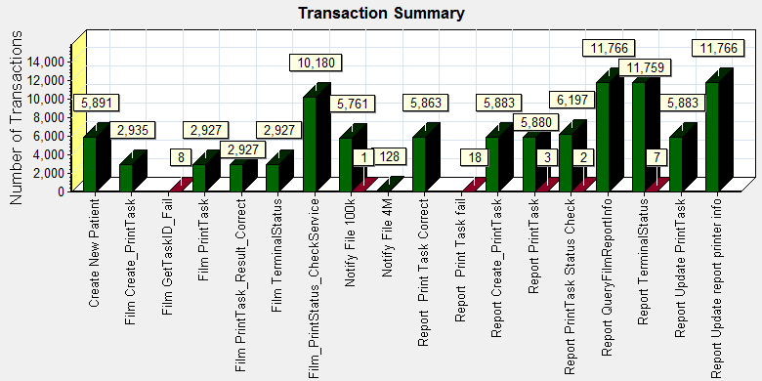

|  |  |  |
| --- | --- | --- |
| **Color** | **Scale** | **Measurement** |
|  | 1 | Pass |
|  | 1 | Fail |

Follow the figure, we can see there are 39 transactions failed during the testing work.

### Transaction response time result of PS

We can get the transaction response time information from the figure as follow:

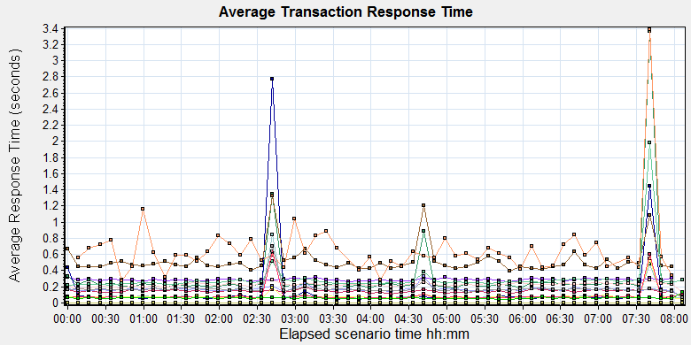

|  |  |  |  |  |  |  |  |  |  |  |  |  |  |  |  |  |  |  |  |  |  |  |  |  |  |  |  |  |  |  |  |  |  |  |  |  |  |  |  |  |  |  |  |  |  |  |  |  |  |  |  |  |  |  |  |  |  |  |  |  |  |  |  |  |  |  |  |  |  |  |  |  |  |  |  |  |  |  |  |  |  |  |  |  |  |  |  |  |  |  |  |  |  |  |  |  |  |  |  |  |  |  |  |  |  |  |  |  |  |  |  |  |  |  |  |  |  |  |  |
| --- | --- | --- | --- | --- | --- | --- | --- | --- | --- | --- | --- | --- | --- | --- | --- | --- | --- | --- | --- | --- | --- | --- | --- | --- | --- | --- | --- | --- | --- | --- | --- | --- | --- | --- | --- | --- | --- | --- | --- | --- | --- | --- | --- | --- | --- | --- | --- | --- | --- | --- | --- | --- | --- | --- | --- | --- | --- | --- | --- | --- | --- | --- | --- | --- | --- | --- | --- | --- | --- | --- | --- | --- | --- | --- | --- | --- | --- | --- | --- | --- | --- | --- | --- | --- | --- | --- | --- | --- | --- | --- | --- | --- | --- | --- | --- | --- | --- | --- | --- | --- | --- | --- | --- | --- | --- | --- | --- | --- | --- | --- | --- | --- | --- | --- | --- | --- | --- | --- | --- |
| |  |  |  |  |  |  |  | | --- | --- | --- | --- | --- | --- | --- | | **Color** | **Scale** | **Measurement** | **Graph's Minimum** | **Graph's Average** | **Graph's Maximum** | **Graph's Median** | |  | 1 | Create New Patient | 0.259 | 0.288 | 0.320 | 0.288 | |  | 1 | Film Create\_PrintTask | 0.183 | 0.312 | 3.363 | 0.228 | |  | 1 | Film PrintTask | 0.114 | 0.147 | 0.200 | 0.148 | |  | 1 | Film PrintTask\_Result\_Correct | 0.000 | 0.000 | 0.000 | 0.000 | |  | 1 | Film TerminalStatus | 0.044 | 0.147 | 2.767 | 0.068 | |  | 1 | Film\_PrintStatus\_CheckService | 0.058 | 0.095 | 0.842 | 0.073 | |  | 1 | Notify File 100k | 0.396 | 0.520 | 1.330 | 0.470 | |  | 1 | Notify File 4M | 0.276 | 0.657 | 3.385 | 0.591 | |  | 1 | Report Print Task Correct | 0.000 | 0.000 | 0.000 | 0.000 | |  | 1 | Report Create\_PrintTask | 0.135 | 0.225 | 0.282 | 0.228 | |  | 1 | Report PrintTask | 0.062 | 0.169 | 0.327 | 0.166 | |  | 1 | Report PrintTask Status Check | 0.042 | 0.083 | 0.552 | 0.073 | |  | 1 | Report QueryFilmReportInfo | 0.221 | 0.295 | 1.988 | 0.257 | |  | 1 | Report TerminalStatus | 0.058 | 0.090 | 0.639 | 0.070 | |  | 1 | Report Update PrintTask | 0.068 | 0.175 | 0.705 | 0.166 | |  | 1 | Report Update report printer info | 0.047 | 0.061 | 0.133 | 0.060 | |
|  |
|  |
| E:\B31_20190628_Terminal_1\Report\dot_trans.gif |
|  |
| |  | | --- | | **Description:**Displays the average time taken to perform transactions during each second of the load test. This graph helps you determine whether the performance of the server is within acceptable minimum and maximum transaction performance time ranges defined for your system. | |

|  |
| --- |
|  |
|  |

Transaction response time

This figure information shows all transaction response time. We can analysis that there are no transaction response time more than 3 seconds. It`s good performance for our system. The system has performance fluctuate every 2 hours, but it can accepted by requirements.

## Test result of Web service

### Test Statistic Report of Web

After the performance testing works, the transactions result of we module as follow:

|  |  |
| --- | --- |
| Analysis Summary | Period: 16/09/2019 16:08:46 - 17/09/2019 00:14:12 |

|  |  |
| --- | --- |
| **Scenario Name:** | D:\Performance\ScenarioPUMA\_MR2\_Performance\_161.lrs |
| **Results in Session:** | c:\Users\administrator\appdata\local\temp\res1378\res1378.lrr |
| **Duration:** | 8 hours, 5 minutes and 26 seconds. |

|  |
| --- |
| Statistics Summary |

|  |  |  |
| --- | --- | --- |
| [**Maximum Running Users:**](file:///D:\Carestream%20Work\MR3\Performance\LR%20result\Web%20result\LR%20Result\20190917_1\Report\Report0.html) |  | 10 |
| [**Total Throughput (bytes):**](file:///D:\Carestream%20Work\MR3\Performance\LR%20result\Web%20result\LR%20Result\20190917_1\Report\Report2.html) | Show SLA Results | 1,468,052,827 |
|  |  |  |
|  |  |  |
| [**Average Throughput (bytes/second):**](file:///D:\Carestream%20Work\MR3\Performance\LR%20result\Web%20result\LR%20Result\20190917_1\Report\Report2.html) | Show SLA Results | 50,402 |
|  |  |  |
|  |  |  |
| [**Total Hits:**](file:///D:\Carestream%20Work\MR3\Performance\LR%20result\Web%20result\LR%20Result\20190917_1\Report\Report1.html) | Show SLA Results | 45,707 |
|  |  |  |
|  |  |  |
| [**Average Hits per Second:**](file:///D:\Carestream%20Work\MR3\Performance\LR%20result\Web%20result\LR%20Result\20190917_1\Report\Report1.html) | Show SLA Results | 1.569 | [**View HTTP Responses Summary**](file:///D:\Carestream%20Work\MR3\Performance\LR%20result\Web%20result\LR%20Result\20190917_1\Report\summary.html#1) |
|  |  |  |  |
|  |  |  |  |

|  |
| --- |
|  |

|  |
| --- |
| Transaction Summary |

|  |  |  |  |  |
| --- | --- | --- | --- | --- |
| [**Transactions:**](file:///D:\Carestream%20Work\MR3\Performance\LR%20result\Web%20result\LR%20Result\20190917_1\Report\Report3.html) | Total Passed: 12,898 | Total Failed: 0 | Total Stopped: 0 | [**Average Response Time**](file:///D:\Carestream%20Work\MR3\Performance\LR%20result\Web%20result\LR%20Result\20190917_1\Report\Report4.html) |

|  |  |  |  |
| --- | --- | --- | --- |
|  | **Pass** | **Fail** | **Stop** |
| Total | 12,898 | 0 | 0 |

|  |  |  |  |  |  |  |
| --- | --- | --- | --- | --- | --- | --- |
| **Transaction Name** | **Minimum** | **Average** | **Maximum** | **Pass** | **Fail** | **Stop** |
| ExpandFilmRecord | 0.007 | 0.345 | 2.195 | 413 | 0 | 0 |
| ExpandReportRecord | 0.006 | 0.033 | 0.68 | 413 | 0 | 0 |
| Reconlication\_Film\_all | 0.584 | 1.165 | 9.044 | 496 | 0 | 0 |
| Reconlication\_Report\_All | 0.028 | 0.153 | 1.988 | 496 | 0 | 0 |
| SetPrintMode | 0.025 | 0.147 | 0.94 | 413 | 0 | 0 |
| SetStatusOfFilmWithExpand\_NOTprinted | 0.289 | 0.524 | 1.492 | 71 | 0 | 0 |
| SetStatusOfFilmWithExpand\_Printed | 0.291 | 0.559 | 2.426 | 75 | 0 | 0 |
| SetStatusOfFilmWithExpand\_Unprinted | 0.269 | 0.471 | 1.575 | 81 | 0 | 0 |
| SetStatusOfFilmWithoutExpand\_NOTprinted | 0.034 | 0.139 | 0.666 | 83 | 0 | 0 |
| SetStatusOfFilmWithoutExpand\_printed | 0.038 | 0.137 | 0.625 | 75 | 0 | 0 |
| SetStatusOfFilmWithoutExpand\_unprinted | 0.034 | 0.141 | 0.703 | 79 | 0 | 0 |
| SetStatusOfReportWithExpand\_NOTprinted | 0.063 | 0.168 | 0.543 | 84 | 0 | 0 |
| SetStatusOfReportWithExpand\_printed | 0.054 | 0.177 | 0.671 | 75 | 0 | 0 |
| SetStatusOfReportWithExpand\_unprinted | 0.057 | 0.214 | 2.478 | 75 | 0 | 0 |
| SetStatusOfReportWithoutExpand\_NOTprinted | 0.048 | 0.139 | 0.333 | 74 | 0 | 0 |
| SetStatusOfReportWithoutExpand\_printed | 0.05 | 0.132 | 0.447 | 71 | 0 | 0 |
| SetStatusOfReportWithoutExpand\_unprinted | 0.052 | 0.141 | 0.727 | 85 | 0 | 0 |
| SetTheHoldingTime | 0.015 | 0.096 | 0.788 | 413 | 0 | 0 |
| Terminal\_monitor | 0.172 | 0.347 | 1.852 | 551 | 0 | 0 |
| User\_login | 0.044 | 0.311 | 4.846 | 2,416 | 0 | 0 |
| worklist\_query\_ACC | 0.013 | 0.037 | 0.172 | 47 | 0 | 0 |
| worklist\_query\_LastMonth | 0.017 | 0.044 | 0.224 | 71 | 0 | 0 |
| worklist\_query\_LastTwoToday | 0.014 | 0.037 | 0.231 | 65 | 0 | 0 |
| worklist\_query\_Lastweek | 0.016 | 0.052 | 0.386 | 62 | 0 | 0 |
| worklist\_query\_Patient\_PatientName | 0.011 | 0.062 | 0.977 | 64 | 0 | 0 |
| worklist\_query\_Patient\_PID | 0.012 | 0.046 | 0.28 | 62 | 0 | 0 |
| Worklist\_Query\_Today | 0.021 | 0.084 | 0.468 | 67 | 0 | 0 |
| WorlkList\_Query\_randomTime | 0.02 | 0.284 | 1.742 | 54 | 0 | 0 |

|  |  |  |  |  |  |  |
| --- | --- | --- | --- | --- | --- | --- |
| **Service Level Agreement Legend:** | D:\Carestream Work\MR3\Performance\LR result\Web result\LR Result\20190917_1\Report\led_ok.gif | Pass | D:\Carestream Work\MR3\Performance\LR result\Web result\LR Result\20190917_1\Report\led_error.gif | Fail | D:\Carestream Work\MR3\Performance\LR result\Web result\LR Result\20190917_1\Report\led_no_data.gif | No Data |

|  |
| --- |
| HTTP Responses Summary |

|  |  |  |  |
| --- | --- | --- | --- |
| **HTTP Responses** | **Total** | **Per second** |  |
| HTTP\_200 | 43,291 | 1.486 |  |
| HTTP\_302 | 2,416 | 0.083 |  |

|  |
| --- |
|  |
| D:\Carestream Work\MR3\Performance\LR result\Web result\LR Result\20190917_1\Report\dot_trans.gif |
|  |
| |  | | --- | | **Filters:**(do not Include Think Time) | |  | |
| D:\Carestream Work\MR3\Performance\LR result\Web result\LR Result\20190917_1\Report\dot_trans.gif |
|  |

Follow the summary report, we can see all the transactions have passed and transaction response time very good.

### Transaction summary result of Web

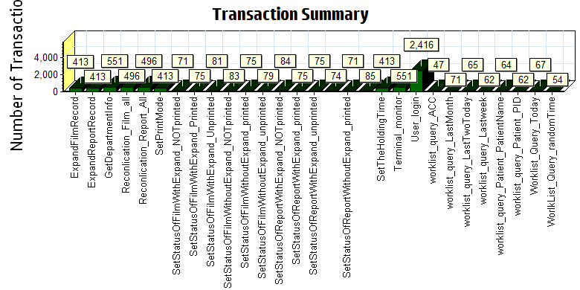

|  |  |  |  |  |  |  |
| --- | --- | --- | --- | --- | --- | --- |
| |  |  |  | | --- | --- | --- | | Color | Scale | Measurement | |  | 1 | Pass | |
|  |
|  |
|  |
|  |
|  |

We can see that there is no transaction failed during the testing works.

### Transaction response time result of Web

We can get the transaction response time information from the figure as follow:

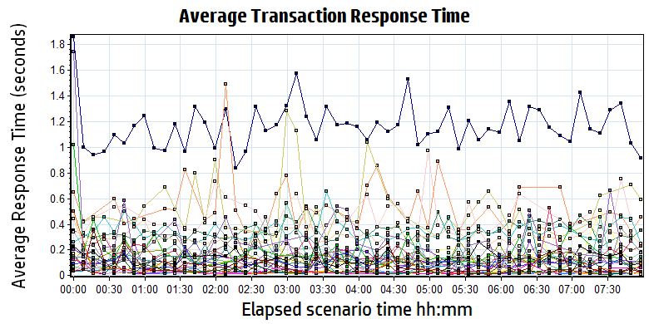

|  |
| --- |
|  |
|  |
|  |
| G:\PUMA MR2\loadrunner result\MR2_B31_20190628_1\Report\dot_trans.gif   |  |  |  |  |  |  |  |  |  |  |  |  |  |  |  |  |  |  |  |  |  |  |  |  |  |  |  |  |  |  |  |  |  |  |  |  |  |  |  |  |  |  |  |  |  |  |  |  |  |  |  |  |  |  |  |  |  |  |  |  |  |  |  |  |  |  |  |  |  |  |  |  |  |  |  |  |  |  |  |  |  |  |  |  |  |  |  |  |  |  |  |  |  |  |  |  |  |  |  |  |  |  |  |  |  |  |  |  |  |  |  |  |  |  |  |  |  |  |  |  |  |  |  |  |  |  |  |  |  |  |  |  |  |  |  |  |  |  |  |  |  |  |  |  |  |  |  |  |  |  |  |  |  |  |  |  |  |  |  |  |  |  |  |  |  |  |  |  |  |  |  |  |  |  |  |  |  |  |  |  |  |  |  |  |  |  |  |  |  |  |  |  |  |  |  |  |  |  |  |  |  |  |  |  |  |  |  |  |  |  |  | | --- | --- | --- | --- | --- | --- | --- | --- | --- | --- | --- | --- | --- | --- | --- | --- | --- | --- | --- | --- | --- | --- | --- | --- | --- | --- | --- | --- | --- | --- | --- | --- | --- | --- | --- | --- | --- | --- | --- | --- | --- | --- | --- | --- | --- | --- | --- | --- | --- | --- | --- | --- | --- | --- | --- | --- | --- | --- | --- | --- | --- | --- | --- | --- | --- | --- | --- | --- | --- | --- | --- | --- | --- | --- | --- | --- | --- | --- | --- | --- | --- | --- | --- | --- | --- | --- | --- | --- | --- | --- | --- | --- | --- | --- | --- | --- | --- | --- | --- | --- | --- | --- | --- | --- | --- | --- | --- | --- | --- | --- | --- | --- | --- | --- | --- | --- | --- | --- | --- | --- | --- | --- | --- | --- | --- | --- | --- | --- | --- | --- | --- | --- | --- | --- | --- | --- | --- | --- | --- | --- | --- | --- | --- | --- | --- | --- | --- | --- | --- | --- | --- | --- | --- | --- | --- | --- | --- | --- | --- | --- | --- | --- | --- | --- | --- | --- | --- | --- | --- | --- | --- | --- | --- | --- | --- | --- | --- | --- | --- | --- | --- | --- | --- | --- | --- | --- | --- | --- | --- | --- | --- | --- | --- | --- | --- | --- | --- | --- | --- | --- | --- | --- | --- | --- | --- | --- | --- | --- | --- | --- | --- | | |  |  |  |  |  |  |  | | --- | --- | --- | --- | --- | --- | --- | | **Color** | **Scale** | **Measurement** | **Minimum** | **Average** | **Maximum** | **Std. Deviation** | |  | 1 | ExpandFilmRecord | 0.007 | 0.345 | 2.195 | 0.181 | |  | 1 | ExpandReportRecord | 0.006 | 0.033 | 0.680 | 0.053 | |  | 1 | GetDepartmentInfo | 0.008 | 0.028 | 0.859 | 0.053 | |  | 1 | Reconlication\_Film\_all | 0.584 | 1.165 | 9.044 | 0.553 | |  | 1 | Reconlication\_Report\_All | 0.028 | 0.153 | 1.988 | 0.162 | |  | 1 | SetPrintMode | 0.025 | 0.147 | 0.940 | 0.135 | |  | 1 | SetStatusOfFilmWithExpand\_NOTprinted | 0.289 | 0.524 | 1.492 | 0.220 | |  | 1 | SetStatusOfFilmWithExpand\_Printed | 0.291 | 0.559 | 2.426 | 0.339 | |  | 1 | SetStatusOfFilmWithExpand\_Unprinted | 0.269 | 0.471 | 1.575 | 0.188 | |  | 1 | SetStatusOfFilmWithoutExpand\_NOTprinted | 0.034 | 0.139 | 0.666 | 0.107 | |  | 1 | SetStatusOfFilmWithoutExpand\_printed | 0.038 | 0.137 | 0.625 | 0.116 | |  | 1 | SetStatusOfFilmWithoutExpand\_unprinted | 0.034 | 0.141 | 0.703 | 0.118 | |  | 1 | SetStatusOfReportWithExpand\_NOTprinted | 0.063 | 0.168 | 0.543 | 0.103 | |  | 1 | SetStatusOfReportWithExpand\_printed | 0.054 | 0.177 | 0.671 | 0.111 | |  | 1 | SetStatusOfReportWithExpand\_unprinted | 0.057 | 0.214 | 2.478 | 0.282 | |  | 1 | SetStatusOfReportWithoutExpand\_NOTprinted | 0.048 | 0.139 | 0.333 | 0.061 | |  | 1 | SetStatusOfReportWithoutExpand\_printed | 0.050 | 0.132 | 0.447 | 0.071 | |  | 1 | SetStatusOfReportWithoutExpand\_unprinted | 0.052 | 0.141 | 0.727 | 0.093 | |  | 1 | SetTheHoldingTime | 0.015 | 0.096 | 0.788 | 0.098 | |  | 1 | Terminal\_monitor | 0.172 | 0.347 | 1.852 | 0.211 | |  | 1 | User\_login | 0.044 | 0.311 | 4.846 | 0.358 | |  | 1 | worklist\_query\_ACC | 0.013 | 0.037 | 0.172 | 0.033 | |  | 1 | worklist\_query\_LastMonth | 0.017 | 0.044 | 0.224 | 0.042 | |  | 1 | worklist\_query\_LastTwoToday | 0.014 | 0.037 | 0.231 | 0.040 | |  | 1 | worklist\_query\_Lastweek | 0.016 | 0.052 | 0.386 | 0.071 | |  | 1 | worklist\_query\_Patient\_PatientName | 0.011 | 0.062 | 0.977 | 0.126 | |  | 1 | worklist\_query\_Patient\_PID | 0.012 | 0.046 | 0.280 | 0.047 | |  | 1 | Worklist\_Query\_Today | 0.021 | 0.084 | 0.468 | 0.088 | |  | 1 | WorlkList\_Query\_randomTime | 0.020 | 0.284 | 1.742 | 0.249 | | |  | |  | | D:\Carestream Work\MR3\Performance\LR result\Web result\LR Result\20190917_1\Report\dot_trans.gif | |  | | |  | | --- | | **Description:**Displays the average time taken to perform transactions during each second of the load test. This graph helps you determine whether the performance of the server is within acceptable minimum and maximum transaction performance time ranges defined for your system. | | |

Follow the figure: we can see that the transaction average response time is less than 3 seconds.

|  |
| --- |
|  |
|  |
|  |
|  |
|  |

|  |
| --- |
|  |
|  |

## Performance bottleneck analysis

### Hardware usage analysis- Main Server

During the testing work, we use the test tool to monitor the main server hardware usage include the CPU, Memory, hard disk and etc.

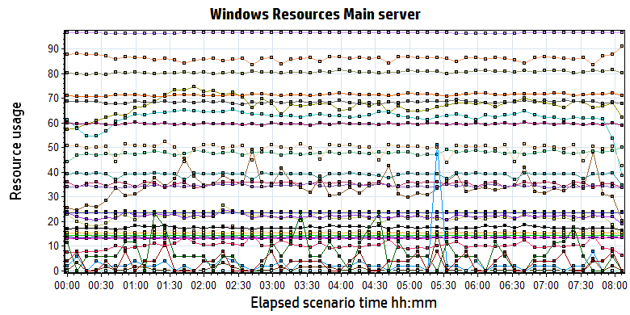

|  |
| --- |
|  |
|  |
|  |
| \\10.184.129.235\puma\Team\Ralf\Performance\ClouldFilm Performance\report_2018_0812\Report\dot_trans.gif   |  |  |  |  |  |  |  |  |  |  |  |  |  |  |  |  |  |  |  |  |  |  |  |  |  |  |  |  |  |  |  |  |  |  |  |  |  |  |  |  |  |  |  |  |  |  |  |  |  |  |  |  |  |  |  |  |  |  |  |  |  |  |  |  |  |  |  |  |  |  |  |  |  |  |  |  |  |  |  |  |  |  |  |  |  |  |  |  |  |  |  |  |  |  |  |  |  |  |  |  |  |  |  |  |  |  |  |  |  |  |  |  |  |  |  |  |  |  |  |  |  |  |  |  |  |  |  |  |  |  |  |  |  |  |  |  |  |  |  |  |  |  |  |  |  |  |  |  |  |  |  |  |  |  |  |  |  |  |  |  |  |  |  |  |  |  |  |  |  |  |  |  |  |  |  |  |  |  |  |  |  |  |  |  |  |  |  |  |  |  |  |  |  |  |  |  |  |  |  | | --- | --- | --- | --- | --- | --- | --- | --- | --- | --- | --- | --- | --- | --- | --- | --- | --- | --- | --- | --- | --- | --- | --- | --- | --- | --- | --- | --- | --- | --- | --- | --- | --- | --- | --- | --- | --- | --- | --- | --- | --- | --- | --- | --- | --- | --- | --- | --- | --- | --- | --- | --- | --- | --- | --- | --- | --- | --- | --- | --- | --- | --- | --- | --- | --- | --- | --- | --- | --- | --- | --- | --- | --- | --- | --- | --- | --- | --- | --- | --- | --- | --- | --- | --- | --- | --- | --- | --- | --- | --- | --- | --- | --- | --- | --- | --- | --- | --- | --- | --- | --- | --- | --- | --- | --- | --- | --- | --- | --- | --- | --- | --- | --- | --- | --- | --- | --- | --- | --- | --- | --- | --- | --- | --- | --- | --- | --- | --- | --- | --- | --- | --- | --- | --- | --- | --- | --- | --- | --- | --- | --- | --- | --- | --- | --- | --- | --- | --- | --- | --- | --- | --- | --- | --- | --- | --- | --- | --- | --- | --- | --- | --- | --- | --- | --- | --- | --- | --- | --- | --- | --- | --- | --- | --- | --- | --- | --- | --- | --- | --- | --- | --- | --- | --- | --- | --- | --- | --- | --- | --- | --- | --- | --- | --- | --- | --- | --- | --- | --- | | |  |  |  |  |  |  | | --- | --- | --- | --- | --- | --- | | **Color** | **Scale** | **Measurement** | **Minimum** | **Average** | **Maximum** | |  | 1 | % Disk Time (PhysicalDisk \_Total):10.184.129.221 | 3.064 | 34.283 | 298.256 | |  | 1 | % Idle Time (PhysicalDisk \_Total):10.184.129.221 | 66.285 | 86.105 | 98.028 | |  | 100 | % Interrupt Time (Processor \_Total):10.184.129.221 | 0.000 | 0.217 | 1.900 | |  | 10 | % Privileged Time (Processor \_Total):10.184.129.221 | 0.173 | 1.584 | 7.168 | |  | 10 | % Processor Time (Processor \_Total):10.184.129.221 | 0.528 | 2.216 | 21.244 | |  | 0.01 | Available MBytes (Memory):10.184.129.221 | 2,366.000 | 2,389.093 | 2,404.000 | |  | 0.001 | Avg. Disk Bytes/Transfer (PhysicalDisk \_Total):10.184.129.221 | 11,457.540 | 47,796.010 | 81,008.390 | |  | 10 | Avg. Disk Queue Length (PhysicalDisk \_Total):10.184.129.221 | 0.092 | 1.028 | 8.948 | |  | 1 | Bytes Total/sec (Network Interface 6TO4 Adapter):10.184.129.221 | 0.000 | 0.000 | 0.000 | |  | 0.001 | Bytes Total/sec (Server):10.184.129.221 | 9,601.404 | 13,598.166 | 22,932.783 | |  | 1E-06 | Cache Bytes (Memory):10.184.129.221 | 32,833,536.000 | 34,478,523.951 | 37,900,288.000 | |  | 1E-09 | Committed Bytes (Memory):10.184.129.221 | 14,343,262,208.000 | 14,358,387,290.626 | 14,381,424,640.000 | |  | 0.01 | Context Switches/sec (System):10.184.129.221 | 1,128.623 | 1,759.746 | 11,501.337 | |  | 1 | Disk Transfers/sec (PhysicalDisk \_Total):10.184.129.221 | 4.323 | 67.242 | 275.668 | |  | 1 | File Data Operations/sec (System):10.184.129.221 | 3.810 | 39.042 | 430.447 | |  | 1E-05 | Free Megabytes (LogicalDisk \_Total):10.184.129.221 | 2,349,214.000 | 2,349,214.000 | 2,349,214.000 | |  | 0.01 | Interrupts/sec (Processor \_Total):10.184.129.221 | 1,422.879 | 6,240.400 | 42,862.101 | |  | 0.1 | Page Faults/sec (Memory):10.184.129.221 | 277.691 | 496.630 | 10,091.979 | |  | 1000 | Page Reads/sec (Memory):10.184.129.221 | 0.000 | 0.003 | 7.971 | |  | 100 | Pages/sec (Memory):10.184.129.221 | 0.000 | 0.009 | 24.246 | |  | 1E-07 | Pool Nonpaged Bytes (Memory):10.184.129.221 | 130,547,712.000 | 132,505,081.353 | 146,014,208.000 | |  | 0.0001 | Pool Nonpaged Bytes (Server):10.184.129.221 | 324,540.000 | 353,525.285 | 369,499.000 | |  | 1E-06 | Pool Paged Bytes (Memory):10.184.129.221 | 96,387,072.000 | 96,532,265.620 | 96,702,464.000 | |  | 0.001 | Pool Paged Bytes (Server):10.184.129.221 | 15,442.000 | 15,442.000 | 15,442.000 | |  | 1 | Pool Paged Failures (Server):10.184.129.221 | 0.000 | 0.000 | 0.000 | |  | 1E-07 | Private Bytes (Process \_Total):10.184.129.221 | 701,177,856.000 | 714,513,658.883 | 734,089,216.000 | |  | 1000 | Processor Queue Length (System):10.184.129.221 | 0.000 | 0.007 | 1.000 | |  | 1000 | Split IO/Sec (PhysicalDisk \_Total):10.184.129.221 | 0.000 | 0.003 | 0.669 | |  | 1E-06 | System Cache Resident Bytes (Memory):10.184.129.221 | 32,833,536.000 | 34,478,510.447 | 37,900,288.000 | |  | 0.1 | Threads (Objects):10.184.129.221 | 661.000 | 684.832 | 731.000 | |  | 0.1 | Threads (System):10.184.129.221 | 576.000 | 596.270 | 644.000 | |  | 1E-07 | Working Set (Process \_Total):10.184.129.221 | 788,705,280.000 | 805,860,024.734 | 837,095,424.000 | | |  | |  | | D:\Carestream Work\MR3\Performance\LR result\PS result\MR3 Performance result\phase1_20190917\Report\dot_trans.gif | |  | | |  | | --- | | **Description:**Displays a summary of the System Resources usage for each Windows based host. | | |
|  |
| |  | | --- | |  | |  | |

Follow this information we can get that:

The main server hardware is works with health status. No bottle neck existed during the testing

### Hardware usage analysis- PS Server

During the testing work, we use the test tool to monitor the PS server hardware usage include the CPU, Memory, hard disk and etc.

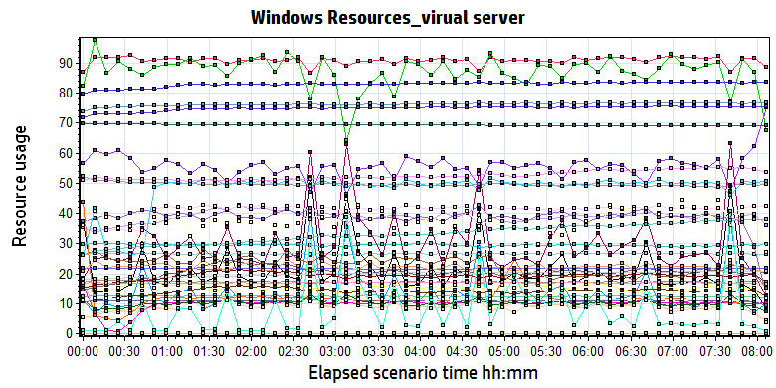

|  |  |  |  |  |  |
| --- | --- | --- | --- | --- | --- |
| **Color** | **Scale** | **Measurement** | **Minimum** | **Average** | **Maximum** |
|  | 0.1 | % Disk Time (PhysicalDisk \_Total):10.184.129.161 | 12.823 | 107.590 | 5,768.467 |
|  | 1 | % Idle Time (PhysicalDisk \_Total):10.184.129.161 | 0.000 | 55.323 | 89.255 |
|  | 100 | % Interrupt Time (Processor \_Total):10.184.129.161 | 0.000 | 0.155 | 1.124 |
|  | 1 | % Privileged Time (Processor \_Total):10.184.129.161 | 0.346 | 12.363 | 21.617 |
|  | 1 | % Processor Time (Processor \_Total):10.184.129.161 | 6.987 | 90.956 | 100.000 |
|  | 0.01 | Available MBytes (Memory):10.184.129.161 | 4,628.000 | 4,965.976 | 6,128.000 |
|  | 0.001 | Avg. Disk Bytes/Transfer (PhysicalDisk \_Total):10.184.129.161 | 7,394.683 | 87,424.933 | 552,839.529 |
|  | 10 | Avg. Disk Queue Length (PhysicalDisk \_Total):10.184.129.161 | 0.257 | 2.152 | 115.369 |
|  | 1 | Bytes Received/sec (Network Interface 6TO4 Adapter):10.184.129.161 | 0.000 | 0.000 | 0.000 |
|  | 1 | Bytes Sent/sec (Network Interface 6TO4 Adapter):10.184.129.161 | 0.000 | 0.000 | 0.000 |
|  | 1 | Bytes Total/sec (Network Interface 6TO4 Adapter):10.184.129.161 | 0.000 | 0.000 | 0.000 |
|  | 1 | Bytes Total/sec (Network Interface isatap.{3F660D18-31C1-45CA-B052-84E45653E92D}):10.184.129.161 | 0.000 | 0.000 | 0.000 |
|  | 1 | Bytes Total/sec (Network Interface isatap.{E18336ED-668D-49B7-9802-4752E741ADA2}):10.184.129.161 | 0.000 | 0.000 | 0.000 |
|  | 0.001 | Bytes Total/sec (Server):10.184.129.161 | 19,173.574 | 26,687.937 | 52,145.957 |
|  | 1E-07 | Cache Bytes (Memory):10.184.129.161 | 170,708,992.000 | 200,094,241.233 | 217,178,112.000 |
|  | 1E-08 | Committed Bytes (Memory):10.184.129.161 | 6,791,692,288.000 | 8,302,879,309.122 | 8,673,058,816.000 |
|  | 0.001 | Context Switches/sec (System):10.184.129.161 | 3,121.626 | 29,574.915 | 53,845.149 |
|  | 10 | Current Disk Queue Length (PhysicalDisk 0 C|):10.184.129.161 | 0.000 | 0.916 | 17.000 |
|  | 10 | Current Disk Queue Length (PhysicalDisk 1 D| E|):10.184.129.161 | 0.000 | 1.363 | 66.000 |
|  | 1E-05 | Disk Read Bytes/sec (PhysicalDisk 0 C|):10.184.129.161 | 0.000 | 1,411,350.070 | 7,161,645.211 |
|  | 1E-05 | Disk Read Bytes/sec (PhysicalDisk 1 D| E|):10.184.129.161 | 0.000 | 989,068.764 | 63,397,860.622 |
|  | 1 | Disk Reads/sec (PhysicalDisk 0 C|):10.184.129.161 | 0.000 | 38.826 | 255.135 |
|  | 1 | Disk Reads/sec (PhysicalDisk 1 D| E|):10.184.129.161 | 0.000 | 11.989 | 671.202 |
|  | 0.1 | Disk Transfers/sec (PhysicalDisk \_Total):10.184.129.161 | 14.884 | 101.400 | 692.126 |
|  | 1E-05 | Disk Write Bytes/sec (PhysicalDisk 0 C|):10.184.129.161 | 165,946.907 | 1,929,408.846 | 7,625,052.786 |
|  | 1E-05 | Disk Write Bytes/sec (PhysicalDisk 1 D| E|):10.184.129.161 | 4,591.760 | 3,899,874.576 | 23,165,640.121 |
|  | 1 | Disk Writes/sec (PhysicalDisk 0 C|):10.184.129.161 | 3.649 | 20.488 | 152.123 |
|  | 1 | Disk Writes/sec (PhysicalDisk 1 D| E|):10.184.129.161 | 3.654 | 30.096 | 450.213 |
|  | 0.001 | File Data Operations/sec (System):10.184.129.161 | 416.859 | 17,336.762 | 31,719.256 |
|  | 1E-05 | Free Megabytes (LogicalDisk \_Total):10.184.129.161 | 6,903,083.000 | 6,938,071.239 | 6,973,153.000 |
|  | 0.001 | Interrupts/sec (Processor \_Total):10.184.129.161 | 3,464.082 | 10,928.540 | 20,080.205 |
|  | 0.0001 | Page Faults/sec (Memory):10.184.129.161 | 189.654 | 111,762.791 | 193,114.686 |
|  | 1 | Page Reads/sec (Memory):10.184.129.161 | 0.000 | 40.978 | 151.112 |
|  | 0.1 | Pages/sec (Memory):10.184.129.161 | 0.000 | 477.531 | 2,747.327 |
|  | 1E-06 | Pool Nonpaged Bytes (Memory):10.184.129.161 | 47,071,232.000 | 52,581,085.870 | 68,030,464.000 |
|  | 1E-05 | Pool Nonpaged Bytes (Server):10.184.129.161 | 1,724,877.000 | 2,296,852.205 | 4,708,425.000 |
|  | 1E-07 | Pool Paged Bytes (Memory):10.184.129.161 | 215,891,968.000 | 217,268,994.585 | 220,655,616.000 |
|  | 0.0001 | Pool Paged Bytes (Server):10.184.129.161 | 209,365.000 | 223,380.810 | 348,025.000 |
|  | 1 | Pool Paged Failures (Server):10.184.129.161 | 0.000 | 0.000 | 0.000 |
|  | 1E-08 | Private Bytes (Process \_Total):10.184.129.161 | 6,123,806,720.000 | 7,489,808,473.043 | 7,714,590,720.000 |
|  | 10 | Processor Queue Length (System):10.184.129.161 | 0.000 | 3.735 | 47.000 |
|  | 1 | Split IO/Sec (PhysicalDisk \_Total):10.184.129.161 | 0.000 | 7.846 | 409.375 |
|  | 1E-07 | System Cache Resident Bytes (Memory):10.184.129.161 | 170,708,992.000 | 200,095,689.561 | 217,178,112.000 |
|  | 0.01 | Threads (Objects):10.184.129.161 | 2,222.000 | 3,319.647 | 3,868.000 |
|  | 0.01 | Threads (System):10.184.129.161 | 1,337.000 | 1,703.934 | 1,826.000 |
|  | 1E-08 | Working Set (Process \_Total):10.184.129.161 | 6,291,234,816.000 | 7,626,249,756.802 | 7,990,747,136.000 |

D:\Carestream Work\MR3\Performance\LR result\PS result\MR3 Performance result\phase1_20190917\Report\dot_trans.gif

|  |
| --- |
| **Description:**Displays a summary of the System Resources usage for each Windows based host. |
|  |

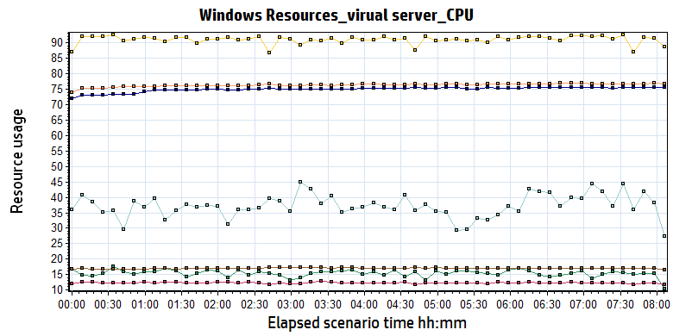

|  |  |  |  |  |  |  |  |  |  |  |  |  |  |  |  |  |  |  |  |  |  |  |  |  |  |  |  |  |  |  |  |  |  |  |  |  |  |  |  |  |  |  |  |  |  |  |  |  |
| --- | --- | --- | --- | --- | --- | --- | --- | --- | --- | --- | --- | --- | --- | --- | --- | --- | --- | --- | --- | --- | --- | --- | --- | --- | --- | --- | --- | --- | --- | --- | --- | --- | --- | --- | --- | --- | --- | --- | --- | --- | --- | --- | --- | --- | --- | --- | --- | --- |
| |  |  |  |  |  |  | | --- | --- | --- | --- | --- | --- | | **Color** | **Scale** | **Measurement** | **Minimum** | **Average** | **Maximum** | |  | 100 | % Interrupt Time (Processor \_Total):10.184.129.161 | 0.000 | 0.155 | 1.124 | |  | 1 | % Privileged Time (Processor \_Total):10.184.129.161 | 0.346 | 12.363 | 21.617 | |  | 1 | % Processor Time (Processor \_Total):10.184.129.161 | 6.987 | 90.956 | 100.000 | |  | 1E-08 | Private Bytes (Process \_Total):10.184.129.161 | 6,123,806,720.000 | 7,489,808,473.043 | 7,714,590,720.000 | |  | 10 | Processor Queue Length (System):10.184.129.161 | 0.000 | 3.735 | 47.000 | |  | 0.01 | Threads (System):10.184.129.161 | 1,337.000 | 1,703.934 | 1,826.000 | |  | 1E-08 | Working Set (Process \_Total):10.184.129.161 | 6,291,234,816.000 | 7,626,249,756.802 | 7,990,747,136.000 | |
|  |
|  |
| D:\Carestream Work\MR3\Performance\LR result\PS result\MR3 Performance result\phase1_20190917\Report\dot_trans.gif |
|  |
| |  | | --- | | **Description:**Displays a summary of the System Resources usage for each Windows based host. | |

The CPU resource has the bottleneck. The average process time is 90%. From the figure, we can see the value is more than 85% during the testing.

The CPU processor queue length is between 30 and 40, it`s more than the threshold value 12. (CPU number \*2 = 6\*2 = 12).

The CPU resource has the neck bottle, most resource is used by the DICOM Ocr service.

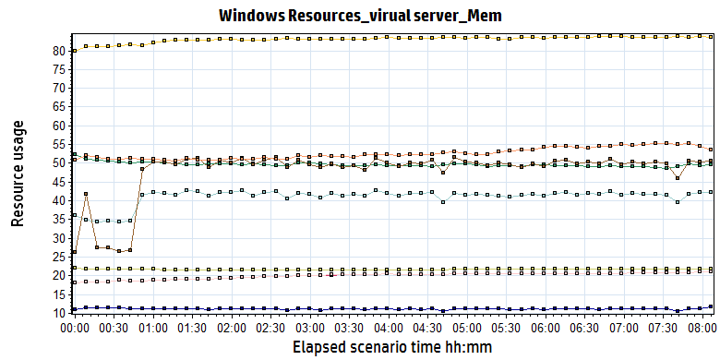

|  |  |  |  |  |  |  |  |  |  |  |  |  |  |  |  |  |  |  |  |  |  |  |  |  |  |  |  |  |  |  |  |  |  |  |  |  |  |  |  |  |  |  |  |  |  |  |  |  |  |  |  |  |  |  |  |  |  |  |  |  |
| --- | --- | --- | --- | --- | --- | --- | --- | --- | --- | --- | --- | --- | --- | --- | --- | --- | --- | --- | --- | --- | --- | --- | --- | --- | --- | --- | --- | --- | --- | --- | --- | --- | --- | --- | --- | --- | --- | --- | --- | --- | --- | --- | --- | --- | --- | --- | --- | --- | --- | --- | --- | --- | --- | --- | --- | --- | --- | --- | --- | --- |
| |  |  |  |  |  |  | | --- | --- | --- | --- | --- | --- | | **Color** | **Scale** | **Measurement** | **Minimum** | **Average** | **Maximum** | |  | 0.01 | Available MBytes (Memory):10.184.129.161 | 4,628.000 | 4,965.976 | 6,128.000 | |  | 1E-07 | Cache Bytes (Memory):10.184.129.161 | 170,708,992.000 | 200,094,241.233 | 217,178,112.000 | |  | 1E-08 | Committed Bytes (Memory):10.184.129.161 | 6,791,692,288.000 | 8,302,879,309.122 | 8,673,058,816.000 | |  | 0.0001 | Page Faults/sec (Memory):10.184.129.161 | 189.654 | 111,762.791 | 193,114.686 | |  | 1 | Page Reads/sec (Memory):10.184.129.161 | 0.000 | 40.978 | 151.112 | |  | 0.1 | Pages/sec (Memory):10.184.129.161 | 0.000 | 477.531 | 2,747.327 | |  | 1E-06 | Pool Nonpaged Bytes (Memory):10.184.129.161 | 47,071,232.000 | 52,581,085.870 | 68,030,464.000 | |  | 1E-07 | Pool Paged Bytes (Memory):10.184.129.161 | 215,891,968.000 | 217,268,994.585 | 220,655,616.000 | |  | 1E-07 | System Cache Resident Bytes (Memory):10.184.129.161 | 170,708,992.000 | 200,095,689.561 | 217,178,112.000 | |
|  |
|  |
| D:\Carestream Work\MR3\Performance\LR result\PS result\MR3 Performance result\phase1_20190917\Report\dot_trans.gif |
|  |
| |  | | --- | | **Description:**Displays a summary of the System Resources usage for each Windows based host. | |

The system used more 6GB memory resource during the testing. The system still have 4.6GB memory can be used. (Available MBytes (Memory):10.184.129.161)

There are many page faults issue during the testing. It means some transactions cannot get the recourse from memory. It need get or request the recourse from hard disk or other device. It needed to enhance in our future version. (Page Faults/sec (Memory)).

The memory resource do not has the bottleneck. There is enough resource for system to use.

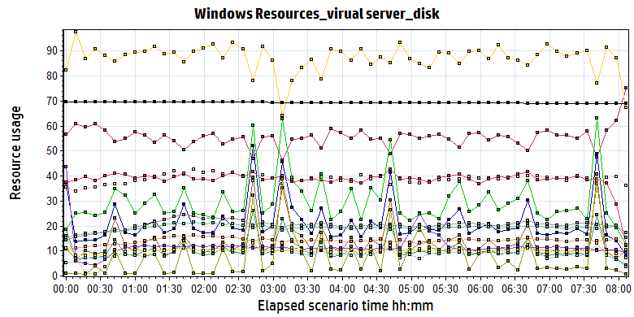

|  |  |  |  |  |  |  |  |  |  |  |  |  |  |  |  |  |  |  |  |  |  |  |  |  |  |  |  |  |  |  |  |  |  |  |  |  |  |  |  |  |  |  |  |  |  |  |  |  |  |  |  |  |  |  |  |  |  |  |  |  |  |  |  |  |  |  |  |  |  |  |  |  |  |  |  |  |  |  |  |  |  |  |  |  |  |  |  |  |  |  |  |  |  |  |  |  |  |  |  |  |  |  |  |  |  |  |  |  |
| --- | --- | --- | --- | --- | --- | --- | --- | --- | --- | --- | --- | --- | --- | --- | --- | --- | --- | --- | --- | --- | --- | --- | --- | --- | --- | --- | --- | --- | --- | --- | --- | --- | --- | --- | --- | --- | --- | --- | --- | --- | --- | --- | --- | --- | --- | --- | --- | --- | --- | --- | --- | --- | --- | --- | --- | --- | --- | --- | --- | --- | --- | --- | --- | --- | --- | --- | --- | --- | --- | --- | --- | --- | --- | --- | --- | --- | --- | --- | --- | --- | --- | --- | --- | --- | --- | --- | --- | --- | --- | --- | --- | --- | --- | --- | --- | --- | --- | --- | --- | --- | --- | --- | --- | --- | --- | --- | --- | --- |
| |  |  |  |  |  |  | | --- | --- | --- | --- | --- | --- | | **Color** | **Scale** | **Measurement** | **Minimum** | **Average** | **Maximum** | |  | 0.1 | % Disk Time (PhysicalDisk \_Total):10.184.129.161 | 12.823 | 107.590 | 5,768.467 | |  | 1 | % Idle Time (PhysicalDisk \_Total):10.184.129.161 | 0.000 | 55.323 | 89.255 | |  | 0.001 | Avg. Disk Bytes/Transfer (PhysicalDisk \_Total):10.184.129.161 | 7,394.683 | 87,424.933 | 552,839.529 | |  | 10 | Avg. Disk Queue Length (PhysicalDisk \_Total):10.184.129.161 | 0.257 | 2.152 | 115.369 | |  | 10 | Current Disk Queue Length (PhysicalDisk 0 C|):10.184.129.161 | 0.000 | 0.916 | 17.000 | |  | 10 | Current Disk Queue Length (PhysicalDisk 1 D| E|):10.184.129.161 | 0.000 | 1.363 | 66.000 | |  | 1E-05 | Disk Read Bytes/sec (PhysicalDisk 0 C|):10.184.129.161 | 0.000 | 1,411,350.070 | 7,161,645.211 | |  | 1E-05 | Disk Read Bytes/sec (PhysicalDisk 1 D| E|):10.184.129.161 | 0.000 | 989,068.764 | 63,397,860.622 | |  | 1 | Disk Reads/sec (PhysicalDisk 0 C|):10.184.129.161 | 0.000 | 38.826 | 255.135 | |  | 1 | Disk Reads/sec (PhysicalDisk 1 D| E|):10.184.129.161 | 0.000 | 11.989 | 671.202 | |  | 0.1 | Disk Transfers/sec (PhysicalDisk \_Total):10.184.129.161 | 14.884 | 101.400 | 692.126 | |  | 1E-05 | Disk Write Bytes/sec (PhysicalDisk 0 C|):10.184.129.161 | 165,946.907 | 1,929,408.846 | 7,625,052.786 | |  | 1E-05 | Disk Write Bytes/sec (PhysicalDisk 1 D| E|):10.184.129.161 | 4,591.760 | 3,899,874.576 | 23,165,640.121 | |  | 1 | Disk Writes/sec (PhysicalDisk 0 C|):10.184.129.161 | 3.649 | 20.488 | 152.123 | |  | 1 | Disk Writes/sec (PhysicalDisk 1 D| E|):10.184.129.161 | 3.654 | 30.096 | 450.213 | |  | 1E-05 | Free Megabytes (LogicalDisk \_Total):10.184.129.161 | 6,903,083.000 | 6,938,071.239 | 6,973,153.000 | |  | 1 | Split IO/Sec (PhysicalDisk \_Total):10.184.129.161 | 0.000 | 7.846 | 409.375 | |
|  |
|  |
| D:\Carestream Work\MR3\Performance\LR result\PS result\MR3 Performance result\phase1_20190917\Report\dot_trans.gif |
|  |
| |  | | --- | | **Description:**Displays a summary of the System Resources usage for each Windows based host. | |
| |  | | --- | |  | |
|  |
|  |
| Follow the figure: we can see that the disk reads and writes operations are very busy. The disk read 2.3MB/S data from disk and write 5.6MB/s data to disk. The Disk is busy but still can accept for design.   |  |  |  |  |  |  | | --- | --- | --- | --- | --- | --- | |  | 1E-05 | Disk Read Bytes/sec (PhysicalDisk 0 C|):10.184.129.161 | 0.000 | 1,411,350.070 | 7,161,645.211 | |  | 1E-05 | Disk Read Bytes/sec (PhysicalDisk 1 D| E|):10.184.129.161 | 0.000 | 989,068.764 | 63,397,860.622 | |  | 1E-05 | Disk Write Bytes/sec (PhysicalDisk 0 C|):10.184.129.161 | 165,946.907 | 1,929,408.846 | 7,625,052.786 | |  | 1E-05 | Disk Write Bytes/sec (PhysicalDisk 1 D| E|):10.184.129.161 | 4,591.760 | 3,899,874.576 | 23,165,640.121 | |

But we can see that there are performance counter has fluctuation every 2 hours. It caused by the database read data from wggc database. We guess it need to flush the view during the testing.

### SQL Server resource usage analysis

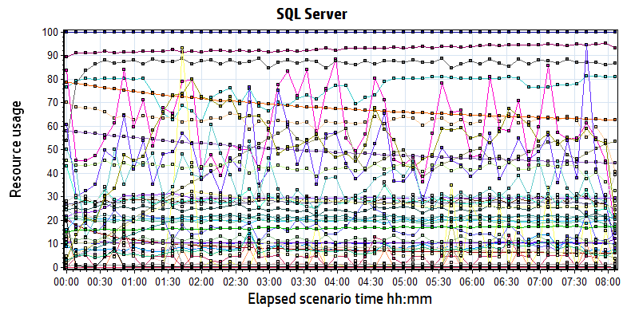

|  |  |  |  |  |  |
| --- | --- | --- | --- | --- | --- |
| **Color** | **Scale** | **Measurement** | **Minimum** | **Average** | **Maximum** |
|  | 10 | Active cursors (MSSQL$GCPACSWS|Cursor Manager by Type \_Total):10.184.129.161 | 0.000 | 1.043 | 4.000 |
|  | 1 | Active parallel threads (MSSQL$GCPACSWS|Workload Group Stats internal):10.184.129.161 | 0.000 | 0.000 | 0.000 |
|  | 1 | Active requests (MSSQL$GCPACSWS|Workload Group Stats internal):10.184.129.161 | 0.000 | 0.000 | 0.000 |
|  | 1 | Active Temp Tables (MSSQL$GCPACSWS|General Statistics):10.184.129.161 | 8.000 | 76.039 | 114.000 |
|  | 10 | Auto-Param Attempts/sec (MSSQL$GCPACSWS|SQL Statistics):10.184.129.161 | 0.000 | 6.268 | 19.931 |
|  | 1 | Average Latch Wait Time (ms) (MSSQL$GCPACSWS|Latches):10.184.129.161 | 0.000 | 8.686 | 474.450 |
|  | 1 | Average Wait Time (ms) (MSSQL$GCPACSWS|Locks \_Total):10.184.129.161 | 0.000 | 60.491 | 3,546.500 |
|  | 1 | Avg. Length of Batched Writes (MSSQL$GCPACSWS|Broker TO Statistics):10.184.129.161 | 0.000 | 0.000 | 0.000 |
|  | 1 | Buffer cache hit ratio (MSSQL$GCPACSWS|Buffer Manager):10.184.129.161 | 89.718 | 99.997 | 100.000 |
|  | 1 | Cache Hit Ratio (MSSQL$GCPACSWS|Catalog Metadata \_Total):10.184.129.161 | 62.805 | 68.602 | 79.071 |
|  | 1 | Cache Hit Ratio (MSSQL$GCPACSWS|Catalog Metadata Printer):10.184.129.161 | 6.130 | 8.592 | 21.379 |
|  | 1 | Cache Hit Ratio (MSSQL$GCPACSWS|Catalog Metadata WGGC):10.184.129.161 | 44.404 | 49.772 | 58.179 |
|  | 1 | Cache Hit Ratio (MSSQL$GCPACSWS|Cursor Manager by Type \_Total):10.184.129.161 | 9.211 | 86.421 | 91.622 |
|  | 1 | Cache Hit Ratio (MSSQL$GCPACSWS|Plan Cache \_Total):10.184.129.161 | 73.944 | 92.933 | 99.514 |
|  | 1 | Checkpoint pages/sec (MSSQL$GCPACSWS|Buffer Manager):10.184.129.161 | 0.000 | 4.323 | 212.983 |
|  | 0.1 | Connection Reset/sec (MSSQL$GCPACSWS|General Statistics):10.184.129.161 | 42.173 | 284.954 | 1,262.879 |
|  | 0.0001 | Cursor memory usage (MSSQL$GCPACSWS|Cursor Manager by Type \_Total):10.184.129.161 | 5,488.000 | 416,109.578 | 617,432.000 |
|  | 10 | Cursor Requests/sec (MSSQL$GCPACSWS|Cursor Manager by Type \_Total):10.184.129.161 | 0.000 | 2.476 | 14.404 |
|  | 0.0001 | Database pages (MSSQL$GCPACSWS|Buffer Manager):10.184.129.161 | 125,763.000 | 291,123.746 | 315,241.000 |
|  | 1 | Errors/sec (MSSQL$GCPACSWS|SQL Errors DB Offline Errors):10.184.129.161 | 0.000 | 0.000 | 0.000 |
|  | 10 | Errors/sec (MSSQL$GCPACSWS|SQL Errors Info Errors):10.184.129.161 | 0.000 | 2.133 | 19.921 |
|  | 1 | Errors/sec (MSSQL$GCPACSWS|SQL Errors Kill Connection Errors):10.184.129.161 | 0.000 | 0.000 | 0.000 |
|  | 1000 | Errors/sec (MSSQL$GCPACSWS|SQL Errors User Errors):10.184.129.161 | 0.000 | 0.001 | 1.990 |
|  | 10000 | Free list stalls/sec (MSSQL$GCPACSWS|Buffer Manager):10.184.129.161 | 0.000 | 0.000 | 0.332 |
|  | 0.0001 | Free pages (MSSQL$GCPACSWS|Buffer Manager):10.184.129.161 | 127.000 | 38,435.407 | 382,808.000 |
|  | 0.1 | Full Scans/sec (MSSQL$GCPACSWS|Access Methods):10.184.129.161 | 60.105 | 276.368 | 621.132 |
|  | 0.001 | Index Searches/sec (MSSQL$GCPACSWS|Access Methods):10.184.129.161 | 5,014.057 | 29,292.062 | 76,985.427 |
|  | 0.1 | Latch Waits/sec (MSSQL$GCPACSWS|Latches):10.184.129.161 | 1.996 | 82.164 | 805.395 |
|  | 100 | Lazy writes/sec (MSSQL$GCPACSWS|Buffer Manager):10.184.129.161 | 0.000 | 0.076 | 21.590 |
|  | 1E-05 | Lock Requests/sec (MSSQL$GCPACSWS|Locks \_Total):10.184.129.161 | 17,057.564 | 1,996,660.531 | 2,995,516.749 |
|  | 1 | Lock Timeouts (timeout > 0)/sec (MSSQL$GCPACSWS|Locks \_Total):10.184.129.161 | 0.000 | 0.000 | 0.000 |
|  | 1 | Lock Timeouts/sec (MSSQL$GCPACSWS|Locks \_Total):10.184.129.161 | 0.000 | 16.579 | 336.103 |
|  | 1 | Lock Wait Time (ms) (MSSQL$GCPACSWS|Locks \_Total):10.184.129.161 | 0.000 | 46.901 | 3,379.889 |
|  | 10 | Lock Waits/sec (MSSQL$GCPACSWS|Locks \_Total):10.184.129.161 | 0.000 | 0.572 | 30.999 |
|  | 0.1 | Logical Connections (MSSQL$GCPACSWS|General Statistics):10.184.129.161 | 122.000 | 197.687 | 240.000 |
|  | 100 | Logins/sec (MSSQL$GCPACSWS|General Statistics):10.184.129.161 | 0.000 | 0.288 | 9.639 |
|  | 100 | Logouts/sec (MSSQL$GCPACSWS|General Statistics):10.184.129.161 | 0.000 | 0.287 | 8.906 |
|  | 100 | Memory Grants Outstanding (MSSQL$GCPACSWS|Memory Manager):10.184.129.161 | 0.000 | 0.359 | 42.000 |
|  | 1 | Memory Grants Pending (MSSQL$GCPACSWS|Memory Manager):10.184.129.161 | 0.000 | 0.000 | 0.000 |
|  | 1 | Number of Deadlocks/sec (MSSQL$GCPACSWS|Locks \_Total):10.184.129.161 | 0.000 | 0.000 | 0.000 |
|  | 1 | Number of SuperLatches (MSSQL$GCPACSWS|Latches):10.184.129.161 | 0.000 | 0.000 | 0.000 |
|  | 1 | Open Connection Count (MSSQL$GCPACSWS|Broker/DBM Transport):10.184.129.161 | 0.000 | 0.000 | 0.000 |
|  | 0.01 | Optimizer Memory (KB) (MSSQL$GCPACSWS|Memory Manager):10.184.129.161 | 1,040.000 | 1,053.905 | 2,408.000 |
|  | 0.0001 | Page life expectancy (MSSQL$GCPACSWS|Buffer Manager):10.184.129.161 | 7,870.000 | 16,577.268 | 4,294,966.000 |
|  | 0.0001 | Page lookups/sec (MSSQL$GCPACSWS|Buffer Manager):10.184.129.161 | 43,477.451 | 167,062.521 | 312,670.618 |
|  | 0.1 | Page reads/sec (MSSQL$GCPACSWS|Buffer Manager):10.184.129.161 | 0.000 | 8.149 | 8,093.597 |
|  | 1 | Page writes/sec (MSSQL$GCPACSWS|Buffer Manager):10.184.129.161 | 0.000 | 53.299 | 531.548 |
|  | 10 | Safe Auto-Params/sec (MSSQL$GCPACSWS|SQL Statistics):10.184.129.161 | 0.000 | 4.256 | 18.142 |
|  | 0.001 | SQL Cache Memory (KB) (MSSQL$GCPACSWS|Memory Manager):10.184.129.161 | 1,904.000 | 25,103.667 | 33,152.000 |
|  | 0.1 | SQL Compilations/sec (MSSQL$GCPACSWS|SQL Statistics):10.184.129.161 | 15.939 | 85.598 | 153.018 |
|  | 100 | SQL Re-Compilations/sec (MSSQL$GCPACSWS|SQL Statistics):10.184.129.161 | 0.000 | 0.119 | 1.661 |
|  | 0.0001 | Stolen pages (MSSQL$GCPACSWS|Buffer Manager):10.184.129.161 | 15,717.000 | 194,728.848 | 232,223.000 |
|  | 0.01 | Total Latch Wait Time (ms) (MSSQL$GCPACSWS|Latches):10.184.129.161 | 0.000 | 736.022 | 69,024.102 |

D:\Carestream Work\MR3\Performance\LR result\PS result\MR3 Performance result\phase1_20190917\Report\dot_trans.gif

|  |
| --- |
| **Description:**Displays a summary of SQL Server Resources. |
|  |

Database result

Follow the SQL server monitor resource, we can find the Database works well during the testing. We changed the parallel timeout value to 60, there is no parallel transactions happened during testing. The database exist the Latch contend issues. It caused by the cluster index structure, memory contented, I/O contented etc. We can enhance these issues in the future version.

### MS IIS resource usage analysis

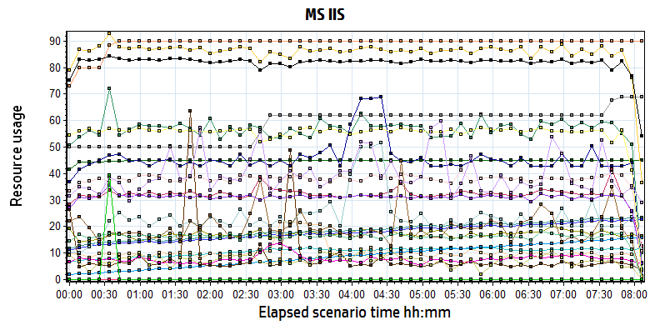

|  |  |  |  |  |  |  |
| --- | --- | --- | --- | --- | --- | --- |
| **Color** | **Scale** | **Measurement** | **Minimum** | **Average** | **Maximum** | **Std. Deviation** |
|  | 1E-07 | # Bytes in all Heaps (.NET CLR Memory \_Global\_):10.184.129.161 | 61,185,148.000 | 171,130,061.637 | 327,765,428.000 | 21,921,057.794 |
|  | 0.01 | # of current logical Threads (.NET CLR LocksAndThreads \_Global\_):10.184.129.161 | 1,009.000 | 1,844.227 | 2,341.000 | 303.616 |
|  | 0.01 | # of current physical Threads (.NET CLR LocksAndThreads \_Global\_):10.184.129.161 | 979.000 | 1,765.587 | 2,262.000 | 299.541 |
|  | 0.1 | # of current recognized threads (.NET CLR LocksAndThreads \_Global\_):10.184.129.161 | 32.000 | 105.394 | 126.000 | 14.537 |
|  | 0.1 | # of Pinned Objects (.NET CLR Memory \_Global\_):10.184.129.161 | 36.000 | 106.154 | 405.000 | 77.835 |
|  | 0.01 | # of total recognized threads (.NET CLR LocksAndThreads \_Global\_):10.184.129.161 | 140.000 | 882.008 | 1,572.000 | 411.318 |
|  | 100 | % Time in GC (.NET CLR Memory \_Global\_):10.184.129.161 | 0.008 | 0.082 | 5.265 | 0.337 |
|  | 1E-06 | Bytes in Loader Heap (.NET CLR Loading \_Global\_):10.184.129.161 | 19,804,160.000 | 44,816,310.571 | 45,400,064.000 | 1,029,435.755 |
|  | 0.01 | Bytes Received/sec (Web Service \_Total):10.184.129.161 | 0.000 | 8,617.953 | 52,301.717 | 4,400.568 |
|  | 0.001 | Bytes Sent/sec (Web Service \_Total):10.184.129.161 | 0.000 | 56,884.338 | 2,055,732.856 | 150,422.191 |
|  | 10 | Contention Rate / sec (.NET CLR LocksAndThreads \_Global\_):10.184.129.161 | 0.000 | 0.778 | 13.617 | 0.796 |
|  | 1 | Current Connections (Web Service \_Total):10.184.129.161 | 0.000 | 32.352 | 62.000 | 3.726 |
|  | 0.001 | Current File Cache Memory Usage (Web Service Cache):10.184.129.161 | 0.000 | 45,884.795 | 75,506.000 | 9,017.325 |
|  | 10 | Current Files Cached (Web Service Cache):10.184.129.161 | 0.000 | 2.349 | 7.000 | 1.089 |
|  | 100 | Current ISAPI Extension Requests (Web Service \_Total):10.184.129.161 | 0.000 | 0.198 | 7.000 | 0.490 |
|  | 10 | Current Metadata Cached (Web Service Cache):10.184.129.161 | 1.000 | 8.914 | 9.000 | 0.393 |
|  | 100 | Current NonAnonymous Users (Web Service \_Total):10.184.129.161 | 0.000 | 0.072 | 3.000 | 0.280 |
|  | 1 | Current URIs Cached (Web Service Cache):10.184.129.161 | 1.000 | 37.962 | 68.000 | 7.066 |
|  | 10 | Get Requests/sec (Web Service \_Total):10.184.129.161 | 0.000 | 3.110 | 33.831 | 2.369 |
|  | 100 | ISAPI Extension Requests/sec (Web Service \_Total):10.184.129.161 | 0.000 | 0.556 | 2.989 | 0.463 |
|  | 100 | Kernel| URI Cache Hits/sec (Web Service Cache):10.184.129.161 | 0.000 | 0.163 | 1.660 | 0.230 |
|  | 1E-06 | Large Object Heap Size (.NET CLR Memory \_Global\_):10.184.129.161 | 13,898,008.000 | 39,648,266.303 | 111,137,000.000 | 15,545,350.016 |
|  | 1 | Locked Errors/sec (Web Service \_Total):10.184.129.161 | 0.000 | 0.000 | 0.000 | 0.000 |
|  | 1 | Maximum Connections (Web Service \_Total):10.184.129.161 | 50.000 | 58.244 | 69.000 | 6.133 |
|  | 10000 | Not Found Errors/sec (Web Service \_Total):10.184.129.161 | 0.000 | 0.000 | 0.663 | 0.007 |
|  | 10 | Post Requests/sec (Web Service \_Total):10.184.129.161 | 0.000 | 8.206 | 19.765 | 1.857 |

D:\Carestream Work\MR3\Performance\LR result\PS result\MR3 Performance result\phase1_20190917\Report\dot_trans.gif

|  |
| --- |
| **Description:**Displays a summary of resources on MsIIS web server. |
|  |

From the finger, we can see that the MS IIS services works well during the testing. But we used too many IIS service in the system. These services used too much memory recourse and they will not release in short time. Maybe we should limit some services recourse usage in future version.

## Database suggesting:

During the testing, we find some issues about the database. We used too much temp table in our system. The database always read 0.3 MB data from wggc database. There are still some views need not exist in our system. Please continue to identify which can be deleted.

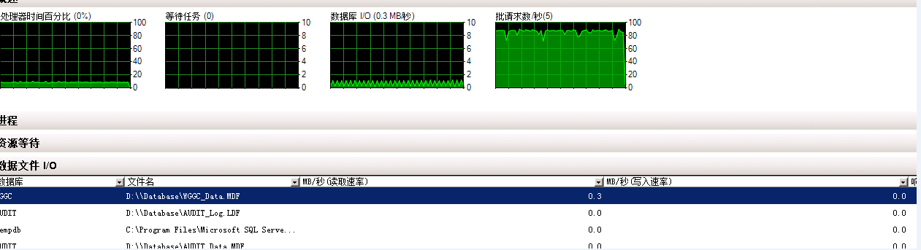

There are some SQL statement tuning suggestion as follow:



There is a SQL patch has installed in system during the testing to resolved the worklist search 500 errors.

QA team has submit the issues to PLI and information as follow:

|  |  |  |
| --- | --- | --- |
| Defect | 100055840 | [Performance] There are 500 errors when query large data from worklist in platform site. |
| Enhance | 100055841 | [Enhance] There are some sql issues need enhance. See the attachments. |

## Test Conclusion

We executed the performance testing scenario for 8 hours. (From Period: 9/16/2019 3:32 PM - 9/16/2019 11:39 PM). There are 39 transaction failed during the testing work. The total pass rate is (98,673 + 12,898 – 39)/ (98,673 + 12,898) = 99.96% > 95%.

During the testing, the main works result is follow:

|  |  |  |
| --- | --- | --- |
| Type | Count | Size |
| Dicom Archived | 2,200 | 10M |
| Dicom Printed | 2,927 | 10M |
| Report Archived | 5,431 | Random 100Kb or 4Mb |
| Report Printed | 5,431 | Random 100Kb or 4Mb |

From the statistic result, **we can get that the result can meets the requirements for system**. The performance enhance operations have fixed some performance issues. The system can works well under the big stress.

During the testing, we stop the LRU and SMS service to avoid the disturbance because these services will not execute in the work times as default. And other limited is we do not add the ROI zone for OCR services, the OCR services is works under a big stress and cause the CPU neck bottle issues. We will reduce some stress for next test works.

**<End of document>**